Homework Lesson 15

Angelika Kryvoruchenko

Level 1

1. Color Contrast on the Page Bug

**Browser** : Chrome **Platform:** Windows

**Description:**

The colour contrast of some of the background colours are too close together and may cause issues for somebody with color blindness

**Steps to reproduce:**

1. Go to the website <https://www.mayoclinic.org/>
2. Scroll down to the block of texts which starts with The No 1 Hospital

**Expected Result:**

Colours should be selected from the colourblind friendly palette

**Actual Result:**

Colours are shades of blue, black and white which are not color blind friendly

2. Menu Tabbing: Arrows do not allow navigation within dropdowns

**Browser** : Chrome **Platform:** Windows

**Description:**

When a user navigates to the dropdown using the tab key, and the drop down expands, the user cannot use the down arrow key to navigate the menu

**Steps to reproduce:**

1. Go to the website <https://www.mayoclinic.org/about-mayo-clinic/>
2. Click Tab until the dropdown “Care at Mayo Clinic” is selected
3. When the dropdown expands, use the down arrow key

**Expected Result:**

Arrows on keyboard should navigate through the drop down menu

**Actual Result:**

Down arrow press causes the page to move down only

3. Job Search parameters are displayed in the browser URL

**Browser** : Chrome **Platform:** Windows

**Description:**

When a user navigates to the job search page, and performs a job search, the URL shows the parameters

**Steps to reproduce:**

1. Go to the website [https://jobs.mayoclinic.org/search-jobs](https://jobs.mayoclinic.org/search-jobs?acm=ALL&alrpm=6252001&ascf=%5B%7B%22key%22:%22ALL%22,%22value%22:%22%22%7D)
2. Search for a job

**Expected Result:**

Browser URL should hide the search parameters

**Actual Result:**

URL shows the full search parameters, for example : [https://jobs.mayoclinic.org/search-jobs?acm=ALL&alrpm=6252001&ascf=[%7B%22key%22:%22ALL%22,%22value%22:%22%22%7D](https://jobs.mayoclinic.org/search-jobs?acm=ALL&alrpm=6252001&ascf=%5B%7B%22key%22:%22ALL%22,%22value%22:%22%22%7D)]

1. Geolocation does not work for recommended jobs display

**Browser** : Chrome **Platform:** Windows

**Description:**

When a user navigates to the job search page, recommended jobs shown are not using geolocation

**Steps to reproduce:**

1. Go to the website [https://jobs.mayoclinic.org/search-jobs](https://jobs.mayoclinic.org/search-jobs?acm=ALL&alrpm=6252001&ascf=%5B%7B%22key%22:%22ALL%22,%22value%22:%22%22%7D)
2. Observe the recommended jobs are not within my location

**Expected Result:**

Geolocation should be used to show relevant jobs

**Actual Result:**

Jobs shown are outside my country

5. Sign in errors are shown as hyperlinks

**Browser** : Chrome **Platform:** Windows

**Description:**

When a user navigates to the sign in page and does not enter required fields, the errors shown have hyperlinks which are not responsive

**Steps to reproduce:**

1. Go to the website <https://apply.mayoclinic.org/TGnewUI/Search/Home/Home?partnerid=25309&siteid=5277#home>
2. Click Sign In
3. Without entering anything, click Sign In button

**Expected Result:**

Errors should not be displayed as hyperlinks

**Actual Result:**

Errors have hyperlinks which do not have any functionality

Level 2

Cross Browser Testing

Chrome all bugs were reproducible

Firefox all bugs were reproducible

Edge all bugs were reproducible

Level 3

* ‘Log in to Patient Account’ in the header

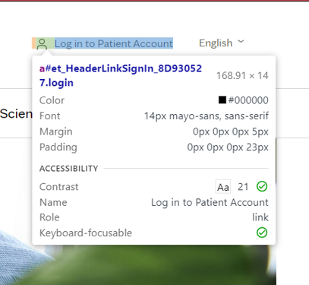

* ‘Learn more about Mayo Clinic’ button

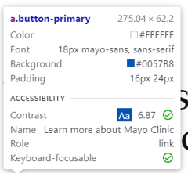

* feedback rate buttons (numbers from 1 to 5, presented within feedback form which

can be called by click on Feedback button (bottom-right corner))

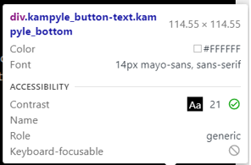

* Language labels for language change

